EL Nino Impact on Electricity Demand Forecasting
Prepared By: Sri Vaisnavi .S
PROBLEM STATEMENT:
The electricity consumption is dependent on the seasonal variation, weather changes, and climatic phenomena like the El Nino. Failure to make accurate predictions of the electricity demands may result in lack of supply, high expenses of operations, and wastage of resources. The objective is to develop an intelligent model that can learn from past demand patterns and climatic factors to predict future electricity demands.

OBJECTIVE:
The development of a machine learning electricity forecast model which would utilize historical data on electricity use and ENSO climatic data to provide accurate 90-day forecasts using a web app.
Features
- Electricity demand forecasting
- 90-day prediction
- Interactive dashboard
- Historical trend visualization
- Download forecast as Excel
- Model performance metrics
Tech Stack
- Python
- Flask
- Pandas
- NumPy
- Scikit-learn
- XGBoost /Random Forest (whichever you used)
- HTML, CSS, JavaScript
- Matplotlib/Plotly (if used)
DATASET:
The dataset was formed by combining historical data on electricity demand from Kaggle and ENSO climate data from NOAA. The datasets were cleaned, normalized according to dates, and engineered using feature engineering techniques to generate a machine learning ready dataset for the period 1980–2025.

DATA PREPROCESSING
- Data integration was carried out by joining electricity demand and ENSO datasets based on the date.
- Missing data and inconsistencies were handled.
- Features such as Year, Month, and Season were created.
- Climate-based features were included.

MACHINE LEARNING WORKFLOW
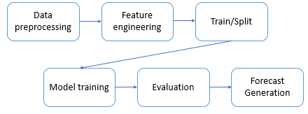

PROJECT STRUCTURE:
elnino-electricity-forecast/
│── app.py
│── model_forest.py
│── electricity_demand_change_model.pkl
│── data/
- elnino_electricity_1980_2025_daily.xlsx
│── templates/
- dashboard.html
- report.html
│── static/
- style.css
│── requirements.txt
│── README.md
INSTALLATION:
git clone < https://github.com/srivaisnavisuresh/ElninovsElectricityDemand >
cd repository-name
pip install -r requirements.txt
HOW TO RUN:
python train_model.py
python app.py
RESULTS:
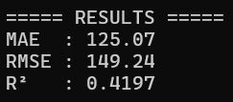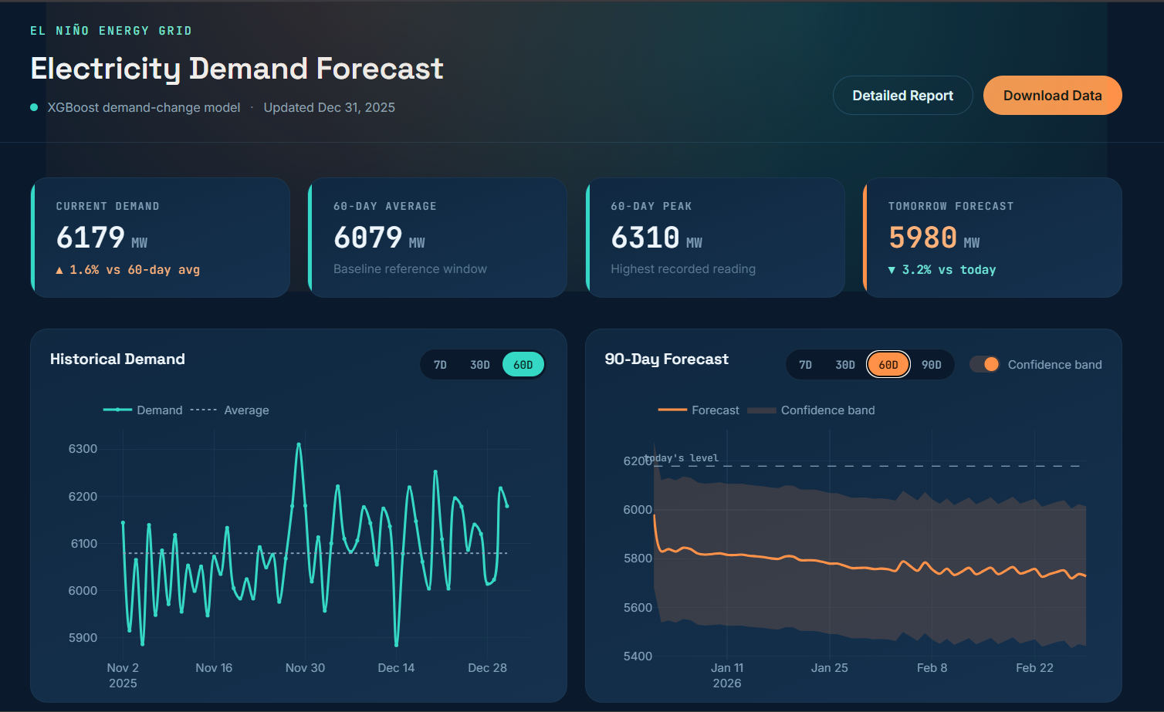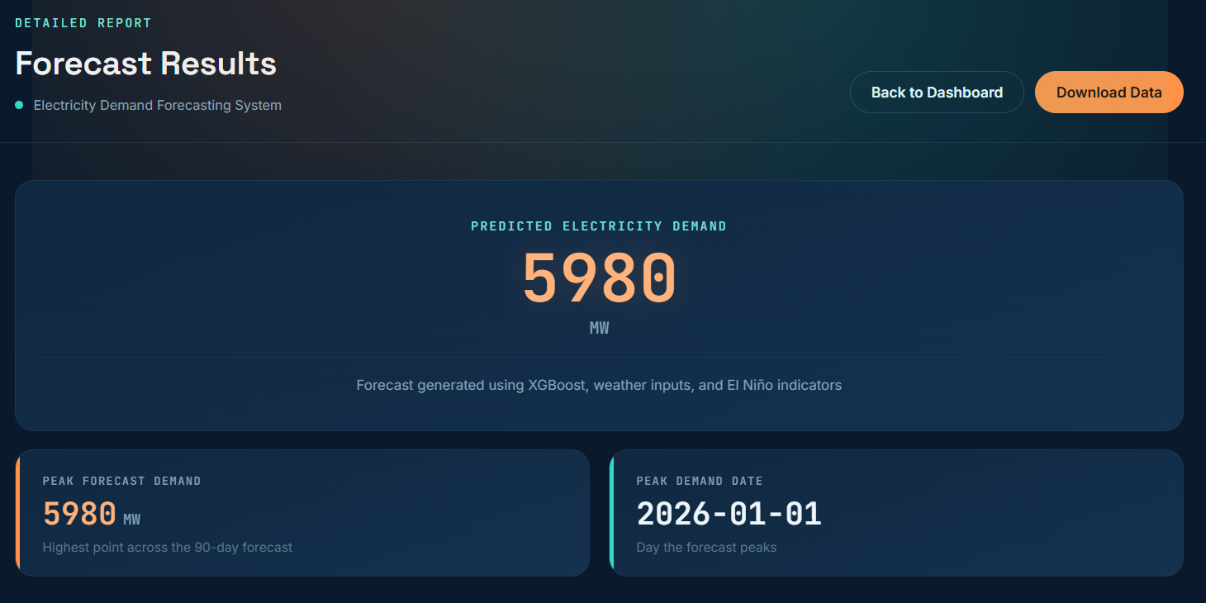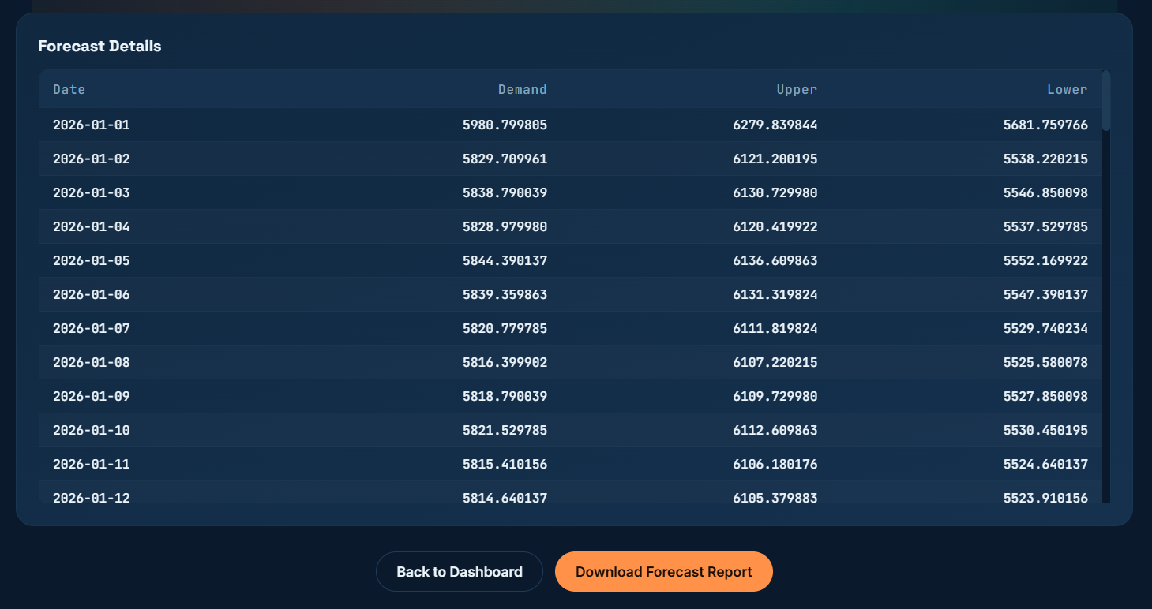
FUTURE ENHANCEMENTS:
- Include weather variables
- Add deep learning models (LSTM)
- Real-time data integration
- Multi-region forecasting

PROJECT ARCHITECTURE:
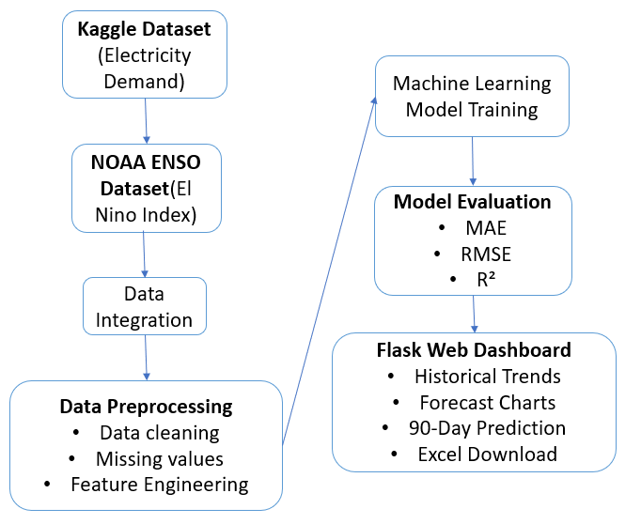
AUTHOR:
- SRI VAISNAVI.S
- https://github.com/srivaisnavisuresh

